**GENERAL PRESENTATION OF THE PROJECT AND THE TEAM**

The Internet has revolutionized many aspects of business and modern development, and promises even more radical changes in the future. Information and communication technologies are transforming the dynamics of doing business every day. Yes, new rules and models. Web applications provide a solution for businesses that are connected to their services, increase the speed of performing service costs and business operations.

Taking the lead from the lack of an online library at the university when we decided to do such a thing with the present web application Online Library. So the idea is in the university we have a library but it cannot access what it does not have virtually. This means that a product will be created that is used by the university and beyond. So the product will not be specific to the university but will have general specifications. The use is only to build a web platform in such a way that different ones can access the information of a certain library. The team of development and management of the work program by these members, whose names are: emermbiemer@gmail.com

**PROCESS**

The online library will automate the process of ordering and delivering various books, reducing the flow of a traditional process and increasing the quality of the process. The information that will be accessed is related to data on various books and journals that are part of any library. The contents of the library are categorized into electronic books which are downloaded from the corresponding web pages or hard copy books which are physically located in the library. The whole system will have several types of individuals with different privileges and functions. First, they make all users (students, teachers or others) ask others about possible books from the library, order books from the library and other special needs requests. Secondly, they are responsible for the maintenance of libraries that have the right to change books and change the condition of books. the third user is the administrator, who has the right to add or remove books, add or remove the access of individuals, the amount of available books, etc.

The process model he does not propose to follow is the evolutionary prototyping model. The reasons and details of this model are listed below:

* The model of the prototyping process with the evolving nature offers the possibilities of processing the initial prototype systems among a number of existing systems while the final stages are always new functionalities.
* Provides continuous feedback to developers.
* Is suitable for projects that are highly visible

**PRODUCT**

Online Library offers members to reduce the time of reserving various books owned by the university library. Users, students in this case, have the opportunity to make online orders through the application and receive at the moment of the search whether the book they want is free or not. After making the order, they must physically appear at the library with an identification tool to retrieve the ordered book. Potential users access all the books that happen to be in the library.

Online Library do a single functionality:

* Keeps connected with inventory (another ledger).

– A book has a title, author and description.

– Inventory also keeps track of the amount of stock/reverses for each book.

* Maintains records for multiple clients.

– A customer can be a member or a non-member.

– A customer for a username (each username is unique), password, email address, phone number and an email address.

– Anyone can register to create a customer account.

* every client who joins.
* Displays a list of books that are available.
* Allows people and managers to log in and out of the system.
* Offers the possibility of editing registered books.
* Allows adding and deleting books from the library.
* Allows the fulfillment of orders by identities.

**SOFTWARE PROJECT DIAGRAMS**

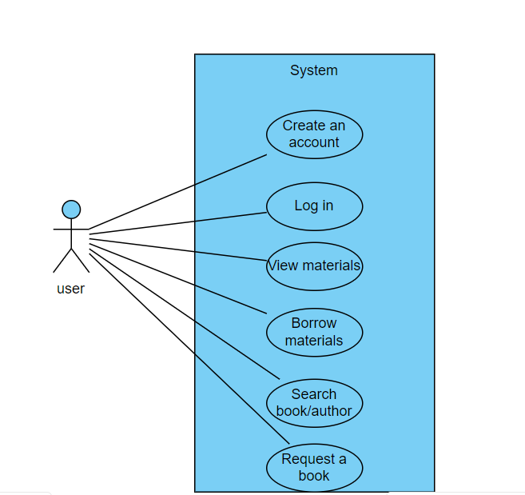**USE CASE DIAGRAM**

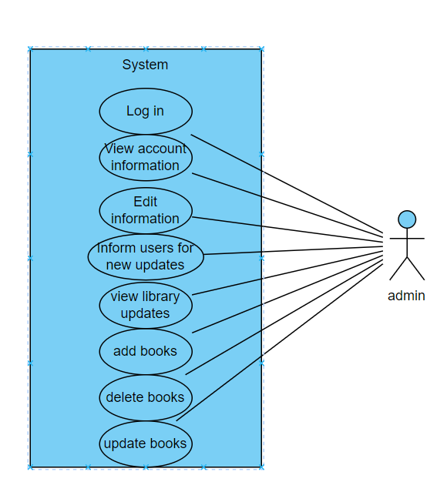

**SEQUENCE DIAGRAM**

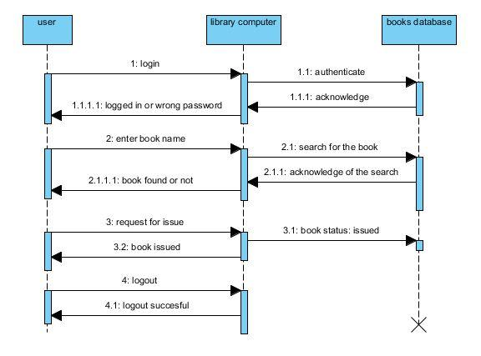

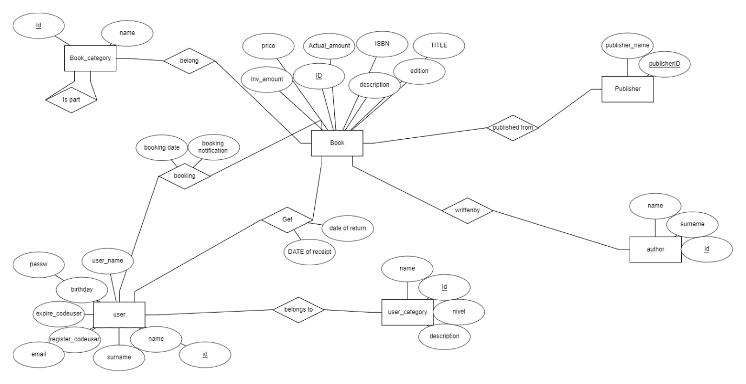 **ER DIAGRAM**